PROJECT SYNOPSIS ON

Stock Price Prediction

Submitted to the Department of Computer Applications

in partial fulfilment of the requirements for the award of the degree Department of Computer Applications (MCA)





Submitted by:

Submitted to:

Mr. Santosh Kumar Gupta

Shakti Sharma (2201330140171)

Sumit Kumar Modi (2201330140193)

NOIDA INSTITUTE OF ENGINEERING AND TECHNOLOGY, GREATER NOIDA

(An Autonomous Institute Affiliated to AKTU, Lucknow) November, 2023

Chapter 1

**INTRODUCTION**

1.1 Introduction of the Project:

The "Stock Price Prediction using Python" project represents a comprehensive solution to one of the most compelling challenges in the financial world – predicting stock prices with precision and insight. This introduction provides an overview of the project's primary objective, its significance, and how it aims to meet the demands of modern investors and financial professionals.

The "Stock Price Prediction using Python" project is designed to harness the power of data and machine learning to provide investors with actionable insights. It leverages historical stock market data, applying various machine learning algorithms and Python programming to analyze and interpret this data. By doing so, it offers forecasts for future stock prices and identifies potential investment opportunities.

1.2 Objective:

The primary objective of this project is to create a reliable and accurate stock price prediction model that can assist investors in identifying potential investment opportunities and managing risks effectively.

1.3 Need of the Project:

The need for stock price prediction tools is paramount in today's fast-paced financial markets. Investors and traders require reliable forecasts to minimize risks and maximize returns. This project addresses the need for accurate, data-driven predictions that can guide investment strategies. It also helps in understanding market sentiment and trends, making it a valuable tool for financial decision-makers.

Chapter 2

**REQUIREMENTS**

2.1 Hardware:

* Processor: Dualcore or above
* RAM: 2GB or above
* Disk Space: 120MB or above

2.2 Software:

**2.2.1 Backend:**

The backend of this project involves Python programming. You'll need the following software components:

* Python
* Data manipulation libraries (Pandas, NumPy)
* Machine learning libraries (Scikit-Learn, TensorFlow)
* Data visualization libraries (Matplotlib)
* Web framework (Flask for web-based deployment)
* Database (MySQL)

**2.2.2 Frontend:**

The project can be enhanced with a user-friendly frontend for data visualization and interaction. The frontend requirements include:

* HTML, CSS, and JavaScript for web development
* Integration with the backend for data presentation and interaction

Chapter 3

**SYSTEM DESIGN**

3.1 DFD (Data Flow Diagram - 0 Level or 1 Level):

A Data Flow Diagram will illustrate how data flows within the system, from data input sources to the prediction output. It will depict the various components and processes involved in stock price prediction.

Level 0 DFD:

The Level 0 DFD is an overview of the entire system and showcases the main processes and data sources without delving into their internal workings. It offers a high-level perspective on how data flows throughout the system.

Entities:

* Stock Data Source: This represents the source of historical stock market data, which can be obtained from various data providers or APIs.
* User: This entity represents the end-users of the system, including investors, traders, and financial analysts.

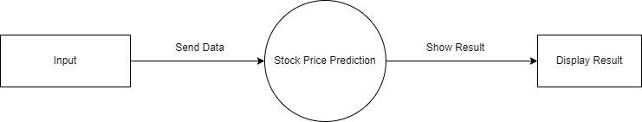

Level 1 DFD:

The Level 1 DFD dives deeper into the processes outlined in the Level 0 DFD, breaking them down into more detailed sub-processes.

Data Collection:

* Data Retrieval: This sub-process involves the retrieval of historical stock market data, which can include tasks like data scraping, API requests, and database queries.
* Data Preprocessing: Here, data cleansing, transformation, and normalization occur to prepare the data for analysis.

User Interaction:

* Input Collection: This sub-process gathers user inputs, including stock selection, date range, and preferred analysis parameters.
* User Authentication: If applicable, this sub-process ensures the user's identity and access rights.

Stock Price Prediction:

* Feature Engineering: Data is processed to create relevant features for the machine learning models.
* Model Training: Machine learning models are trained on the historical data.
* Prediction Generation: The trained models generate stock price predictions based on the user's inputs.

Data Presentation:

* Visualization: This sub-process is responsible for creating visualizations and charts to represent the predictions and insights.
* Report Generation: It generates reports summarizing the predictions and relevant details.
* 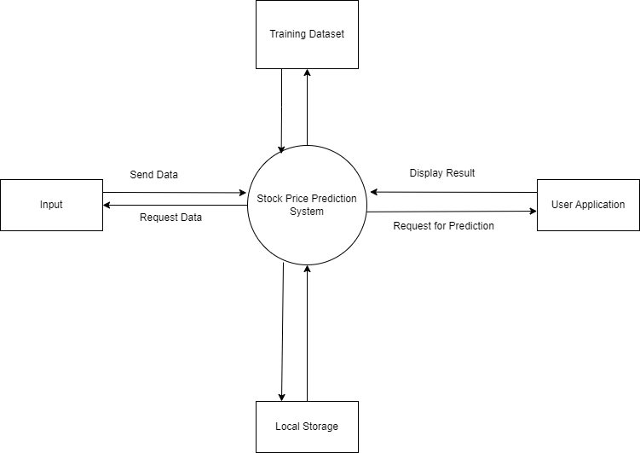User Interaction: Users can interact with the visualized data, exploring the predictions in real-time.

3.3 Process Flow Chart:

A sequential or process flow chart will outline the step-by-step processes involved in stock price prediction, including data preprocessing, feature selection, model training, and result generation.

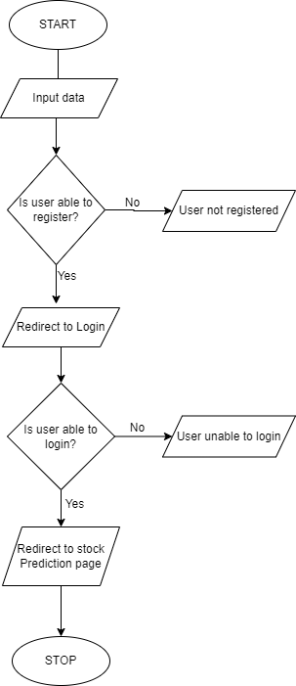

6.3 UML Diagrams

UML (Unified Modelling Language) is a standard language for specifying, visualizing, constructing, and documenting the artifacts of software systems. UML was created by the Object Management Group (OMG) and UML 1.0 specification draft was proposed to the OMG in January 1997. It was initially started to capture the behaviour of complex software and non-software system and now it has become an OMG standard. This tutorial gives a complete understanding on UML.

6.3.1 Use case diagram

The purpose of use case diagram is to capture the dynamic aspect of a system.

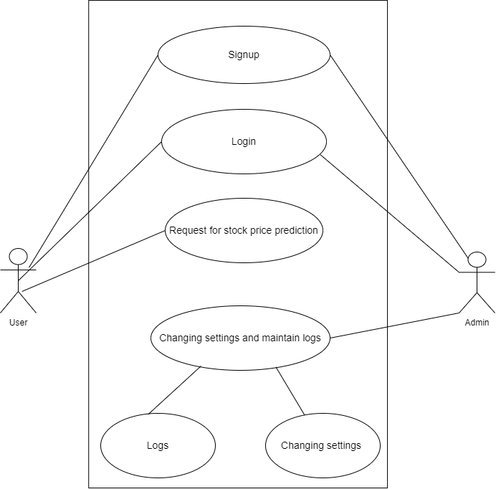

6.3.2 Entity - Relationship Diagram

The purpose of ER diagram is to show the relationship between the entities (here User, Admin and Stocks).

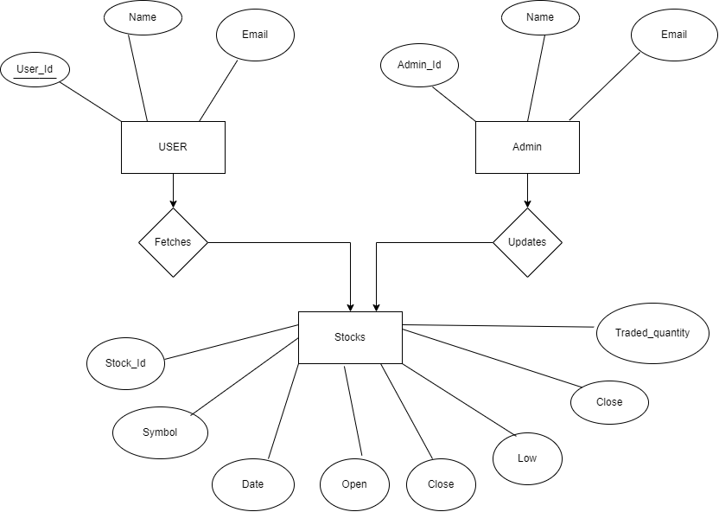

6.3.3 Activity Diagram

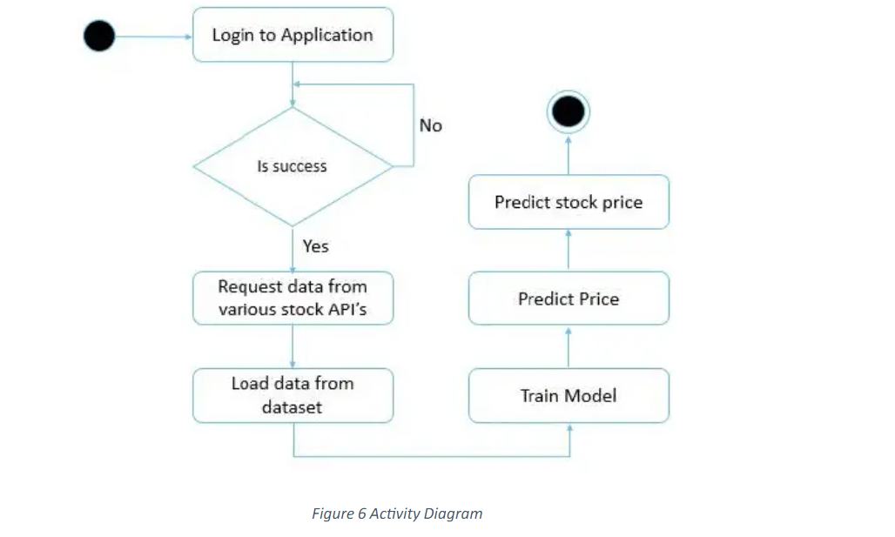The basic purposes of activity diagram is similar to other four diagrams. It captures the dynamic behaviour of the system. Other four diagrams are used to show the message flow from one object to another, but activity diagram is used to show message flow from one activity to another.

Chapter 4

**CONCLUSION**

In conclusion, the stock price prediction project aims to address the pressing need for accurate and data-driven forecasting in financial markets. By leveraging modern technologies and data analysis techniques, this system will empower investors and traders to make more informed and confident decisions. It is a step toward reducing the uncertainty and risk associated with stock market investments.

Chapter 5

**REFERENCES**

* [www.google.com](http://www.google.com/)
* www.researchgate.net
* [www.scribd.com](http://www.scribd.com/)
* [www.youtube.com](http://www.youtube.com/)